Chapter 11, Problem 52.

In the circuit shown in Fig. 11.71, device A receives 2 kW at 0.8 pf lagging, device B receives 3 kVA at 0.4 pf leading, while device C is inductive and consumes 1 kW and receives 500 VARs.

(a) Determine the power factor of the entire system.
(b) Find I given that V_{s} = 120∠45° V.

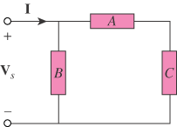

Figure 11.71
For Prob. 11.52.

